**Assignment 12**

**Task 1. Try to make a report which has a page for each kind of Image. When you click the image of that creature you will see all the animals of the same type: To get you started look in the above folder to find the three images used. Note the names of the images. Create a page with a table for each.When the pages are all created, hide them so that the only way user can reach the page is by clicking the relevant image on the first page.**

1. First create Main page called “Choose ”.Place all the image parallelly.Use Text Box from Insert options and type “Choose” in the provided space.

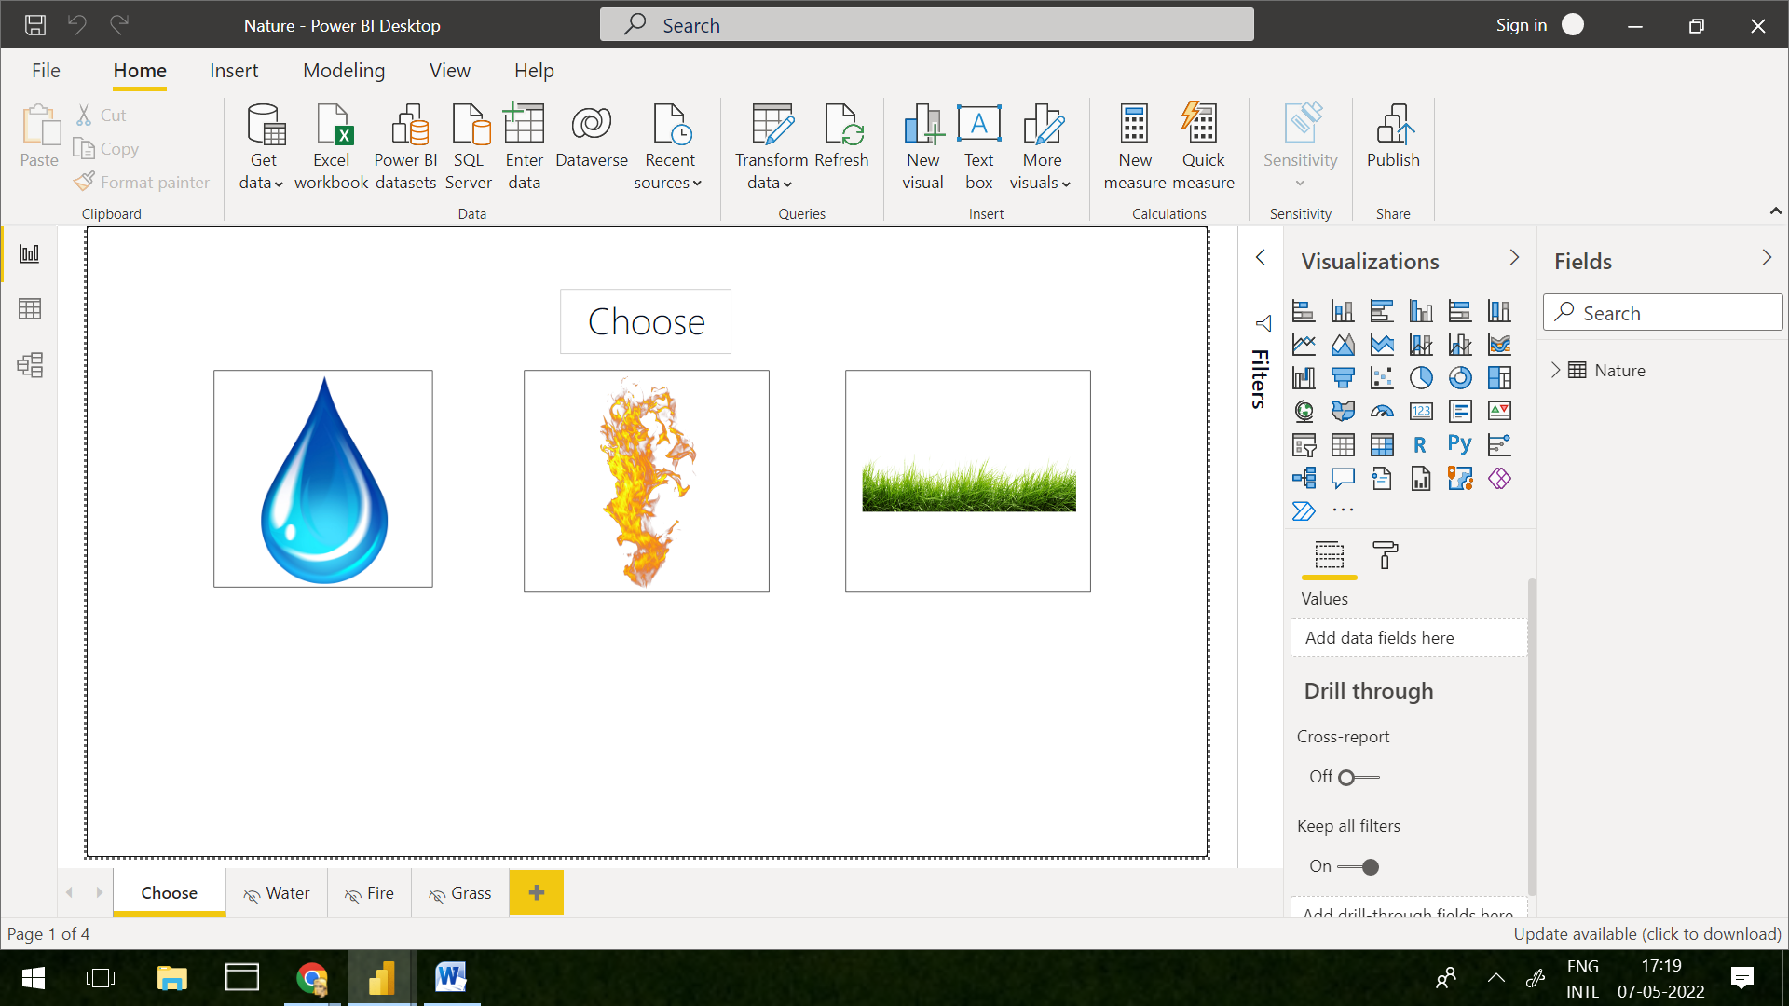

**Task 2. To create the bookmarks make sure you have the bookmark feature turned on in the View tab.Adding a back arrow which returns you to the first page of the report. Use the type Back instead of Bookmark when creating the Link.**

1. Create another page.Rename it to “Water”. Select Table visualization.Place all the columns in Values field from Nature Table. Reorganise and Resize as per page size.
2. Add Text box and back button fromInsert option.Link back button with back option in dropdown.
3. In the view option, click on Bookmark.Select Add and rename it to Water.Right click and update the bookmark
4. Navigate to Choose Page.Select Water visual and under action select Bookmark in the Type dropdown and select Water dropdown from the list.

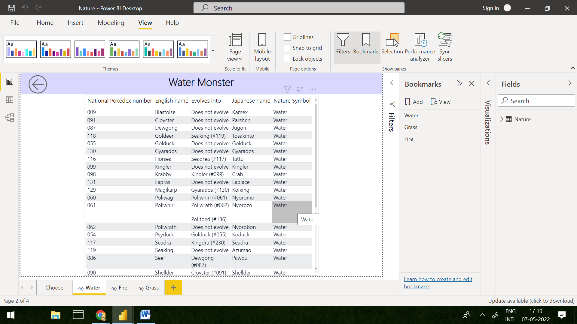

1. Repeat Steps 2 to 5 to create Fire and Grass Bookmarks.

